# Learning document of HTML with Python.

## What is Flask?

• **Flask** is a **Python framework** for **building websites** (or web applications).

• It's **very lightweight**, **easy to learn**, and **perfect for beginners**.

• Think of Flask like a **toolbox** 🧰 that gives you the basic things you need to **build a web server** and **show web pages**.

## How Flask Works?

For example:  
**So, Flask sits at the reception desk**,

* **When someone visits** (like typing your website URL),
* Flask **listens to the request**,
* Then **runs your Python code**,
* And **gives back a webpage** (an HTML file).

*from flask import Flask*

*app = Flask(__name__)*

*@app.route('/')*

*def home():*

*return "Welcome to my website!"*

*if __name__ == '__main__':*

*app.run(debug=True)*

When you **open the browser** and go to **http://127.0.0.1:5000/**,  
You will **see**:

"Welcome to my website!"

**Because Flask** caught your request and **sent back this message**.

## An webpage I have created it’s explanation:

*@app.route('/')*

*def index():*

*return render_template('index.html')*

Line 1 : Explanation  
• This **connects a URL** (called a *route*) to a **Python function**.

• Here '/' means **home page** (when someone visits your site like http://127.0.0.1:5000/).

• So you are saying: "**when someone opens the homepage, run the next function**".

Line 2 & 3: Explanation  
• This is the **Python function** that will be **called** when someone visits /.

• The function is named index(), but you could name it anything (example: home(), start() etc.).

• It **decides what to send back** to the visitor.

• render_template means:  
👉 "**find the HTML file**" (inside a templates/ folder)  
👉 "**and show it**" to the user.

• 'index.html' is the name of your web page file (you already wrote it!).

|  |
| --- |
| **User types http://127.0.0.1:5000/ in browser** |
| Flask sees '/' route |
| Runs the index() function |
| index() says "show index.html" |
| User sees the webpage on their screen |

### What is <http://127.0.0.1:5000/>?

• 127.0.0.1 is **your own computer's IP address** (also called localhost).

• 5000 is the **port** Flask is using to listen for visitors.

• The **/** at the end means: "open the home page (root page)".

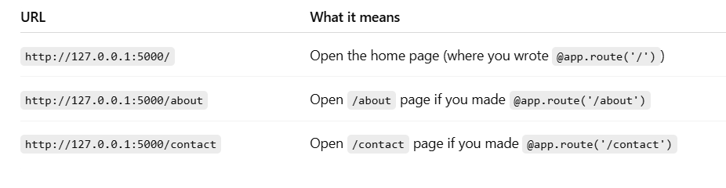

### Route calculate working in both python and HTML

*<form action="/calculate" method="post">*

✅ This form will send data to the Flask route /calculate using POST method.

*<input type="number" name="num1" required>*

*<select name="operation">*

*<option value="add">Add</option>*

*<option value="subtract">Subtract</option>*

*<option value="multiply">Multiply</option>*

*<option value="divide">Divide</option>*

*</select>*

*<input type="number" name="num2" required>*

*<button type="submit">Calculate</button>*

✅ Here user enters:

num1 → first number input

operation → what operation (add/subtract/multiply/divide)

num2 → second number input

Button → to submit the form.

*@app.route('/calculate', methods=['POST'])*

*def calculate():*

✅ When form is submitted to /calculate, this Python function is called. When we fill up the form with all parameters like number1, number2, operator and hit Calculate button. The function calculate is called in the code to do operation.

*operation = request.form['operation']*

*num1 = float(request.form['num1'])*

*num2 = float(request.form['num2'])*

✅ Flask reads the values:

request.form['num1'] → number 1

request.form['operation'] → operation selected

request.form['num2'] → number 2

✅ Based on what user selected:

* It runs add(), subtract(), multiply(), or divide() functions.

*return render_template('home.html', result=result)*

✅ After calculation, Flask loads home.html again, ✅ And sends the calculated result back to the page.

*{% if result is not none %}*

*<h2><i>Result: {{ result }}</i></h2>*

*{% endif %}*

✅ Inside home.html,

✅ If result exists, it shows the value dynamically.  
